# NSSA221 Systems Administration I

# Scripting Assignment 02 – System Report

**The Basics:**

Your manager has tasked you with collecting information from all company systems, a challenging task due to their large number and off-site locations. Fortunately, you have root access and can use SSH for remote access. However, manually running commands on each system is inefficient. Your assignment is to create a script that automates the process of gathering system information from each host.

**Script Requirements:**

Write your script, "*system_report.py*," in Python 3 and save it in the /home/student directory on the Rocky 8 VM in RLES. This script is intended for use in the enterprise environment, not personal laptops. Its functionality and adherence to requirements will be evaluated by the instructor or teaching assistant, using "*Table 1 – Script Grading Rubric*" as a guideline for awarding points.

Your task is to create a Python 3 script named "*system_report.py*" to collect system information across the organization. The script should produce output that is clear, well-organized, and directed to standard output, and redirected to a log file in the user's home directory. Name the file with the system's hostname, followed by "_system_report.log" (e.g., "europa_system_report.log"). Essential Linux commands and Python modules like '**os**' and '**platform**' are crucial. Use specific commands like '**free**', '**ip** **a'**, '**netstat**', and '**df**', and check files like */etc/resolv.conf* and */etc/proc* for relevant data.

This script draws from many of the topics covered in Task Automation Using Interpretive Languages. However, if you have not taken the course, then you will need to reference many Linux commands and rely heavily on the manual pages for the following commands to gather the required information. For Python 3, many modules are available, including but not limited to **os** and **platform**. For example, **platform.system()** will return the operating system. Alternatively, you can leverage the **os** and **subprocess** modules and use many of the available Linux commands listed below.

* For information on RAM use the **free** command.
* For network information, use **ip a**, **netstat**, and **ip route** commands.
* For DNS examine the */etc/resolv.conf* file.
* For system disk information, use the **df** command.
* Examine the contents of the /*etc/proc* file for CPU specs and /*etc/*release* for operating system information.

**Figure 1** – Sample Output

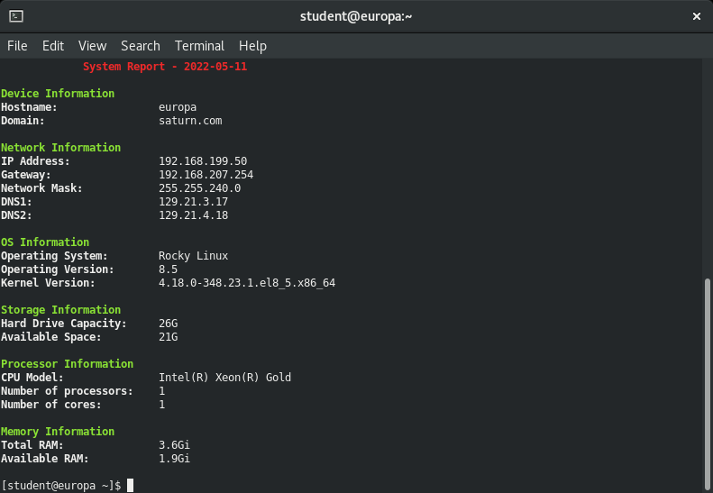

**Please Note:** You will not receive credit for hard coding any of the requirements, they must be derived from the system.

**Table 1** – Script Grading Rubric

|  |  |  |
| --- | --- | --- |
| Requirements | Points | Points Earned |
| Script contains the shebang! | 3 |  |
| Script has executable permissions set. | 3 |  |
| Script is commented with student’s name and date. | 2 |  |
| Script is titled “*system_report.py*” | 2 |  |
| Script clears the terminal when it runs. | 3 |  |
| Script is run to standard output AND redirected to a log file. | 3 |  |
| Report shows current date. | 3 |  |
| Report correctly shows the device’s host name. | 3 |  |
| Report correctly shows the device’s domain suffix. | 3 |  |
| Report correctly shows the device’s IPv4 address. | 3 |  |
| Report correctly shows the device’s default gateway. | 3 |  |
| Report correctly shows the device’s network mask. | 3 |  |
| Report correctly shows the device’s primary and secondary DNS servers. | 3 |  |
| Report correctly shows the device’s operating system. | 3 |  |
| Report correctly shows the device’s operating system version. | 3 |  |
| Report correctly shows the device’s kernel version. | 3 |  |
| Report correctly shows the size of the device’s system disk. | 3 |  |
| Report correctly shows the available space on the system disk. | 3 |  |
| Report correctly shows the CPU Model. | 3 |  |
| Report correctly shows the number of CPUs. | 3 |  |
| Report correctly shows the number of CPU cores. | 3 |  |
| Report correctly shows the device’s total RAM. | 3 |  |
| Report correctly shows the device’s available RAM. | 3 |  |
| The report is organized an easily readable format. | 3 |  |
| The script is sufficiently commented. | 5 |  |
| The script is written in Pythonic style. | 5 |  |
| Scripts runs with no errors. | 10 |  |
| Script is fully functional and runs as expected. | 10 |  |
| Total | |  |